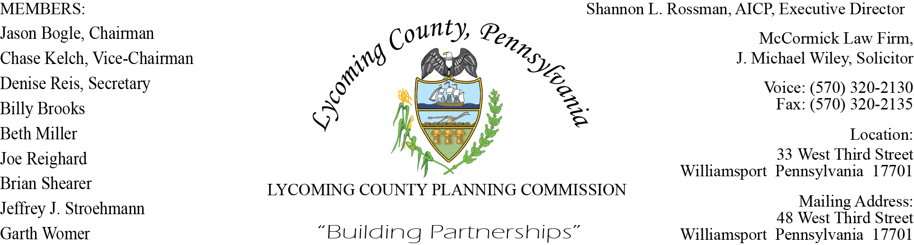
LYCOMING COUNTY PLANNING COMMISSION MEETING MINUTES
TSP – 3RD Floor, LYCO Conference Room #319
August 21, 2025
6:00 P.M.
- CALL TO ORDER – Meeting was called to order at 6:00 p.m.

Members present – Jason Bogle, Garth Womer, Jeffrey Stroehmann, Denise Reis, Chase Kelch, Joe Reighard, Beth Miller, Billy Brooks.

Others present – Joshua Billings, Moses Stoltzfus, Enos Stoltzfus, Daniel Vassallo, Shannon Barnes, J. Michael Wiley, Jenny Picciano, Jennifer Bates, Ed Feigles, Angela Scocchera, Mark Haas, Chris Hodges.

- MINUTES OF REGULAR MEETING – June 19, 2025

There was not a meeting held on July 17, 2025, therefore a Motion was made to accept the minutes of the June 19, 2025 meeting as presented by Denise Reis, Motion was second by Chase Kelch. Motion carried.

- PUBLIC COMMENT ON AGENDA ITEMS ONLY – NONE

- OLD & FUTURE BUSINESS – NONE

Jason Bogle did switch the order of items 5 and 6 on the agenda, choosing to address Action Items first which was item 6. Action items will be listed as item 5 in these minutes, Subdivision & Land Development Plans will be listed as item 6.
- ACTION ITEMS

- Vote to accept the resignation of Planning Commission member Brett Bowes. Joe Reighard made the motion to accept the resignation, Beth Miller second the motion. Motion carried.
- William (Billy) Brooks was introduced and has been assigned as a new member of the Lycoming County Planning Commission.

- SUBDIVISION & LAND DEVELOPMENT PLANS

- Minor Plans Report –Joe Reighard made a motion to ratify the Minor Plans Report as submitted, Beth Miller second the Motion. Motion carried.
- Stoltzfus Land Development– Chris Hodges and Dan Vassallo gave a review of the plan and conditions. Motion was made for approval with conditions regarding the Land Development Plan for the Stoltzfus Land Development by Billy Brooks, Joe Reighard second the motion. Motion carried.

- PRESENTATION – NONE

- COMMITTEE REPORTS/DISCUSSION – NONE

- MONTHLY REPORTING
These reports were for the months of June and July.

- Land Use Staff Meeting Reports
- UPI Reports
- Major Plans Report
- Incomplete Submission Update
- ZHB Case Log
There were no questions regarding the monthly reports.
- DISCUSSION ITEMS - NONE

- PUBLIC COMMENTS – NONE

- ADJOURNMENT – There were no more questions or comments at this time. Joe Reighard made the Motion to Adjourn, Beth Miller second the motion. Meeting was adjourned at 6:39 p.m.
Respectfully submitted,

___________________________ ___________________________
Jenny Picciano, Director Denise Reis, Secretary

DATE:______________________ DATE:______________________

